Nicholas Kamper and Eric Henderson

Lab 4

# Introduction

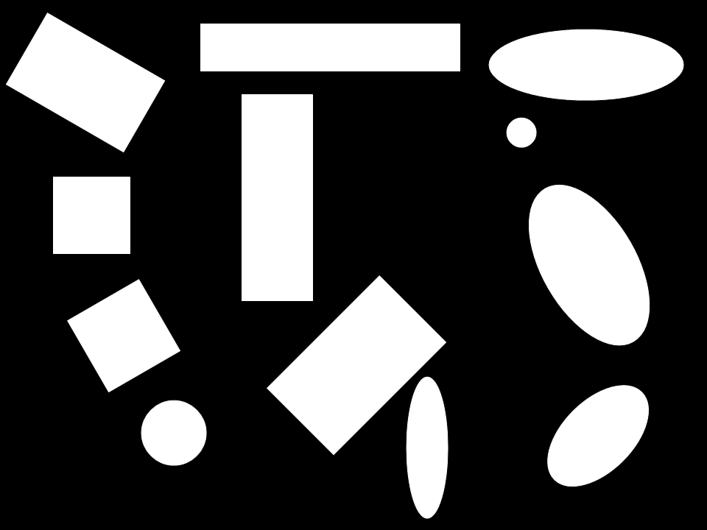Being able to determine the shape of an object in an image gives us additional information that we can use to determine the actual identity of the object. For instance, for our fruit finder, we could’ve used shape to distinguish better between apples/oranges and bananas. Combined with color, this would’ve improved our results significantly.

One potential way to classify shapes is to use their elongation and circularity values. For the given binary image, shown to the right, we calculated the elongation and circularity values, and then tried to guess what the shape was given just the elongation and circularity values and the thresholds we had determined for them.

# Table of Elongation and Circularity Values

|  |  |  |  |  |
| --- | --- | --- | --- | --- |
| Actual Shape | Classified Shape | Elongation | C1 | C2 |
| Rectangle | Ellipse | 1.632636 | 19.253100 | 5.039302 |
| Square | Square | 1.000000 | 15.696689 | 9.066172 |
| Square | Square | 1.000599 | 17.945742 | 9.097953 |
| Circle | Circle | 1.000506 | 13.740122 | 169.702151 |
| Rectangle | Rectangle | 5.431390 | 30.168839 | 2.144193 |
| Rectangle | Rectangle | 2.897043 | 20.747111 | 2.875815 |
| Rectangle | Ellipse | 1.673929 | 16.866295 | 4.881031 |
| Ellipse | Rectangle | 3.349763 | 22.246603 | 2.627978 |
| Ellipse | Ellipse | 2.717045 | 19.424259 | 3.051360 |
| Circle | Circle | 1.006457 | 13.360337 | 82.523430 |
| Ellipse | Ellipse | 1.860104 | 15.930455 | 4.751504 |
| Ellipse | Ellipse | 1.733395 | 15.402312 | 5.445088 |

Squares have ~1 elongation values while having low C2 values, while circles have ~1 elongation values while having high C2 values. We can clearly distinguish between squares and circles, leaving the main problem of distinguishing between ellipses and rectangles. In the case of shape #8, it’s very difficult to tell that it is an ellipse based on its circularity values. As such, using our thresholds, we definitely misclassify between ellipses and rectangles quite frequently, especially for elongated ellipses.

## Thresholds used for classification

**Circle:** C2 > 25

**Square:** not circle and Elongation < 1.05

**Rectangle:** not circle or square and C1 > 20

**Ellipse:** everything else

# Future Work

One potential way to improve the shape detector would be to use the radial representation of the image along with the first and second derivatives to determine the shape curvature. Once we find the primary axis, we can determine the difference between a rectangle and an ellipse by looking at how it behaves in the first quadrant.

 

As you can tell, an ellipse has an always-increasing or always-decreasing radial distance from the centroid, while the rectangle has the sharp peak and then changes direction.